Spring framework important Common Interview Questions
1. What is maven?
Answer:- Maven is build management tools, It is for defining how your .java files get compiled to .class and then packaged into .jar /.war /.ear files. Example :- Apache maven
Building means in spring:-
- Downloading dependencies
- Putting additional jars on a class path, compiling source code into binary code
- Running tests
- Packaging compiled code into deployable artifacts such as JAR, WAR, and ZIP files
- Deploying these artifacts to an application server or repository.
2. What is Spring framework:-
Ans:- Spring is a framework for dependency injection. Which is a pattern that allows to build very decoupled systems.
3. Spring project basics things:-
- groupId – a unique base name of the company or group that created the project
- artifactId – a unique name of the project
- version – a version of the project
- packaging – a packaging method (e.g. WAR/JAR/ZIP)
The first three of these (groupId:artifactId:version) combine to form the unique identifier and are the mechanism by which you specify which versions of external libraries (e.g. JARs) your project will use.
4. Project Object Model(POM.XML)
Ans :- The configuration of a Maven project is done via a Project Object Model (POM), represented by a pom.xml file. The POM describes the project, manages dependencies, and configures plugins for building the software.
The POM also defines the relationships among modules of multi-module projects. Let's look at the basic structure of a typical POM file:
5. Difference between plugin and dependency?
Ans :- Plugin is a tool you use at the execution of your maven build. The most of the work in maven is done using plugins
E.g:- you use a compiler-plugin to compile the java files.
Dependency means kind of library which you will use in your code. Dependency is just a Jar file which will be added to the class path while executing the tasks.
E.g:- The Jar files to be added to the class path while compiling the file, will be specified as a
dependency.

6. What is IoC?
Answer: IoC (Inversion of Control) is a design principle where the Spring container manages the creation and lifecycle of objects instead of the application code.
Instead of creating objects using the new keyword, Spring creates, configures, and manages them.

7. What is an IoC Container?
Answer: The IoC Container is core concept of spring framework that creates, configures, destroy, manages beans and also injects dependencies into beans.
It also performs Dependency Injection, reducing tight coupling and improving maintainability
8. What are the types of IoC Containers?
Answer:
- BeanFactory
- ApplicationContext (most commonly used) (it is way of implementation of IOC container)

9. Which IoC Container is used in Spring Boot?
Answer: ApplicationContext is used by default in Spring Boot.

10. What is the difference between BeanFactory and ApplicationContext?
BeanFactory | ApplicationContext
It’s provided Basic container | It’s provided Advanced container
It’s Lazy initialization | It’s Eager initialization (singleton beans)
It’s Limited features | It’s Supports AOP, events, i18n, and more
Less commonly used | It’s preferred in Spring Boot

11. How many ways configure IOC container
Ans:-By 3 ways => XML, annotation, java configuration file.
12. Gives Example and what is difference between IoC vs Dependency Injection (DI) :-
IoC | Dependency Injection
It’s Design principle | Implementation of IoC
Controls object creation | Injections required dependencies
Implemented by Spring Container | I achieved using Constructor injection, Setter injection and Field Injection

D.I Example:
@Repository
public interface UserRepository implements jpaReposioty<User, Long> {
}
@Service
public class UserService {
private final UserRepository repository;
public UserService(UserRepository repository) {
this.repository = repository;
}
}
This is constructor injection, which is the recommended approach.

IOC Example:-
Without IoC :-
The developer creates the object manually.
public class UserService {
private UserRepository repository = new UserRepository();
public void display() {
repository.save();
}
}
Problem
- Tight coupling
- Difficult test
- Hard to maintain

With IoC
Spring creates objects.
@Repository
public class UserRepository {
public void save() {
System.out.println("Data Saved");
}
}
@Service
public class UserService {
@Autowired
private UserRepository repository;
public void display() {
repository.save();
}
}
Here:
- Spring creates UserRepository
- Spring creates UserService
- Spring injects UserRepository into UserService

No need to use:
new UserRepository();

Why is it called Inversion of Control?
Normally:
Developer → Creates Objects
With Spring:
Spring Container → Creates Objects
The control of object creation is inverted from the developer to the Spring framework.

Responsibilities of IoC Container
- Bean creation
- Dependency Injection (DI)
- Bean configuration
- Bean lifecycle management
- Scope management (Singleton, Prototype, etc.)

Types of IoC Containers
1. BeanFactory
- Basic IoC container
- Lazy initialization (bean created only when requested)
- Lightweight
- Mainly used in simple applications
Example:
BeanFactory factory = new XmlBeanFactory(resource);

2. ApplicationContext (Most Used)
- Advanced IoC container
- Eager initialization (singleton beans are created at startup)
- Supports:
  - Dependency Injection
  - Events
  - Internationalization (i18n)
  - AOP
  - Bean lifecycle management
Example:
ApplicationContext context = new AnnotationConfigApplicationContext(AppConfig.class);
In Spring Boot, ApplicationContext is created automatically.

What is annotation ?
It provides the additional information to compiler, and we can use in it on the method, class, fields, interface etc.

About @Component and @Bean Annotations:-
In Spring Boot, both @Component and @Bean are used to create objects that’s manages by IoC (Inversion of Control) Container, but they are used differently.

Difference:-
@Component is used to mark a class for automatic bean creation through component scanning. container.
@Component is typically used for application classes.
@Bean is used inside a @Configuration class to explicitly create and register a bean in the Spring.
@Bean is preferred for third-party classes or when custom object creation logic is required.`
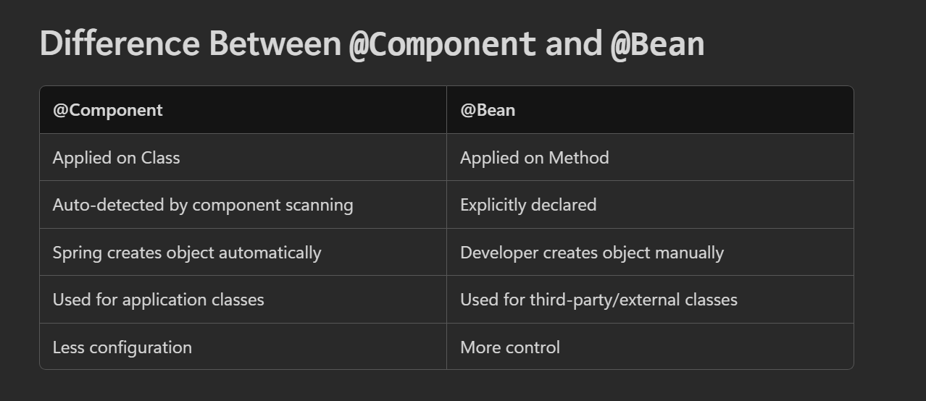

@Bean Example:-
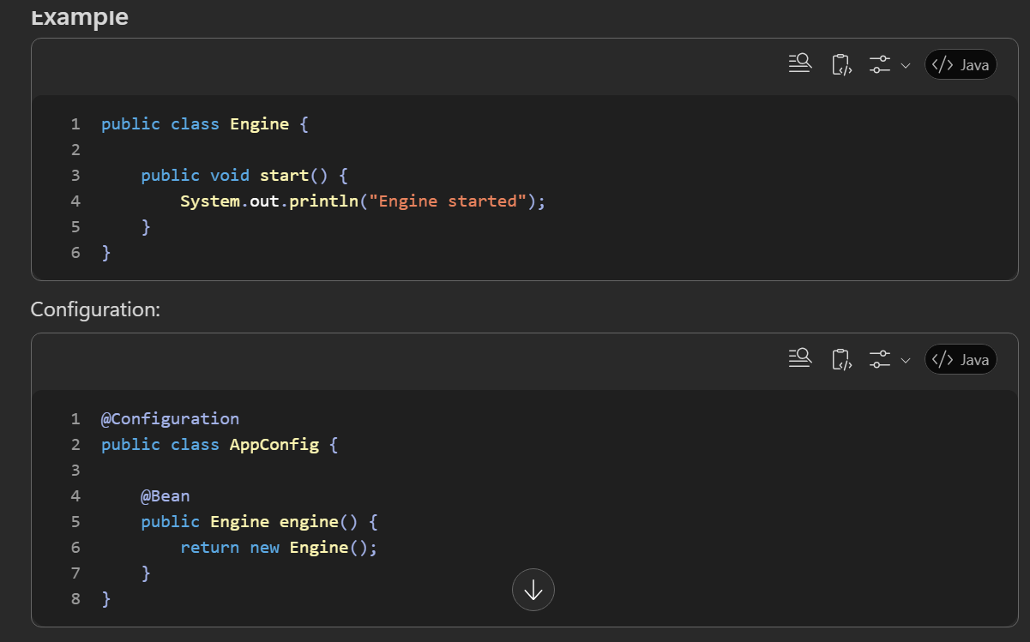
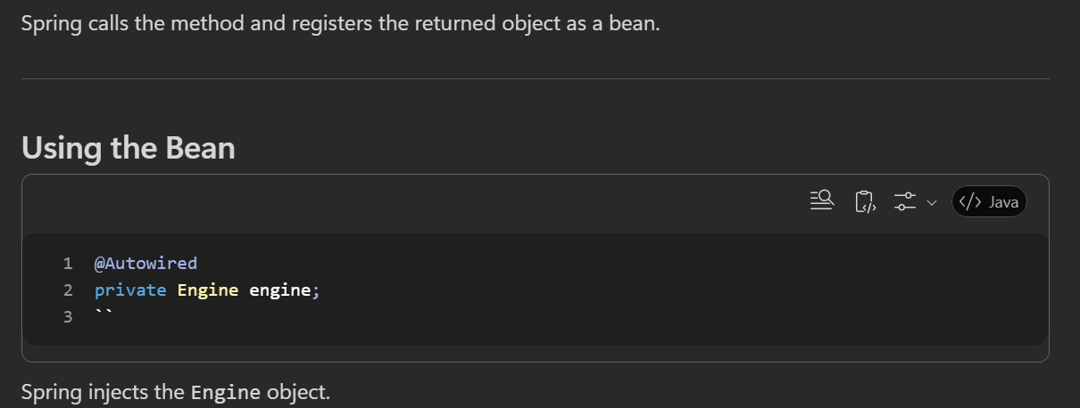

@Component Example:-
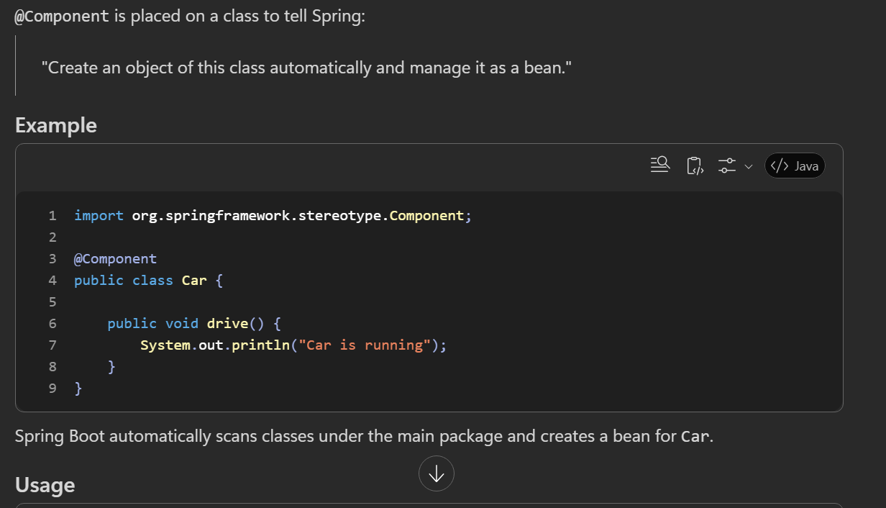
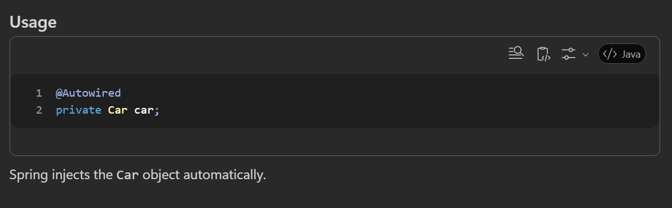

How @Compoenet work:-
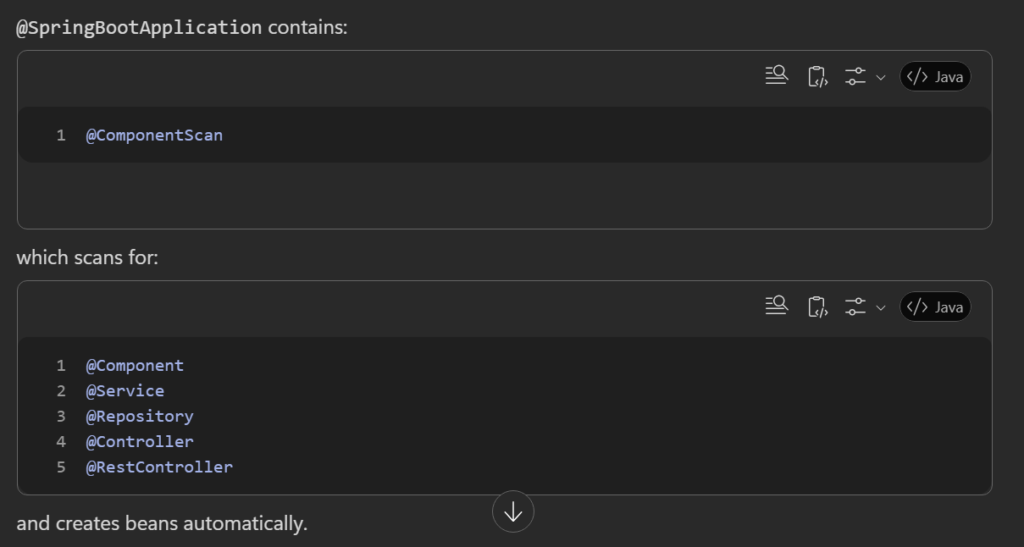
Bean Lifecycle in IoC Container
Application Starts
↓
Spring Container Starts
↓
Bean Created
↓
Dependencies Injected
↓
@PostConstruct
↓
Bean Ready to Use
↓
Application Running
↓
@PreDestroy
↓
Bean Destroyed
What is Bean Scope in Spring Boot?
Ans :- In Spring Boot, bean scope defines the lifecycle and number of instances created for a bean. The most common and default scope is singleton, where only one instance exists in the Spring container.
Other scopes include prototype (new instance every time),
request (one per HTTP request),
session (one per user session), and
application (one per web application).
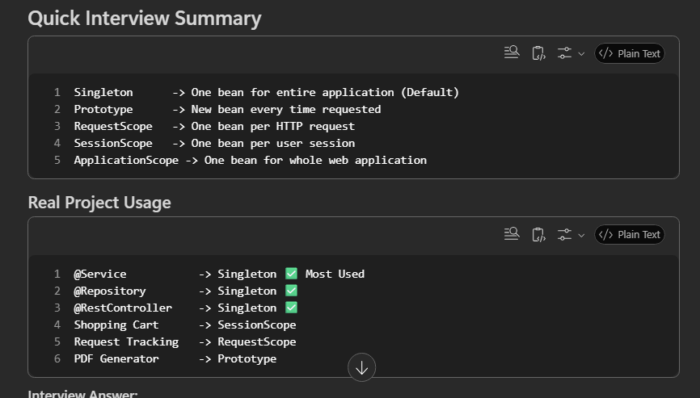
Example of all 5 types of bean scope:-
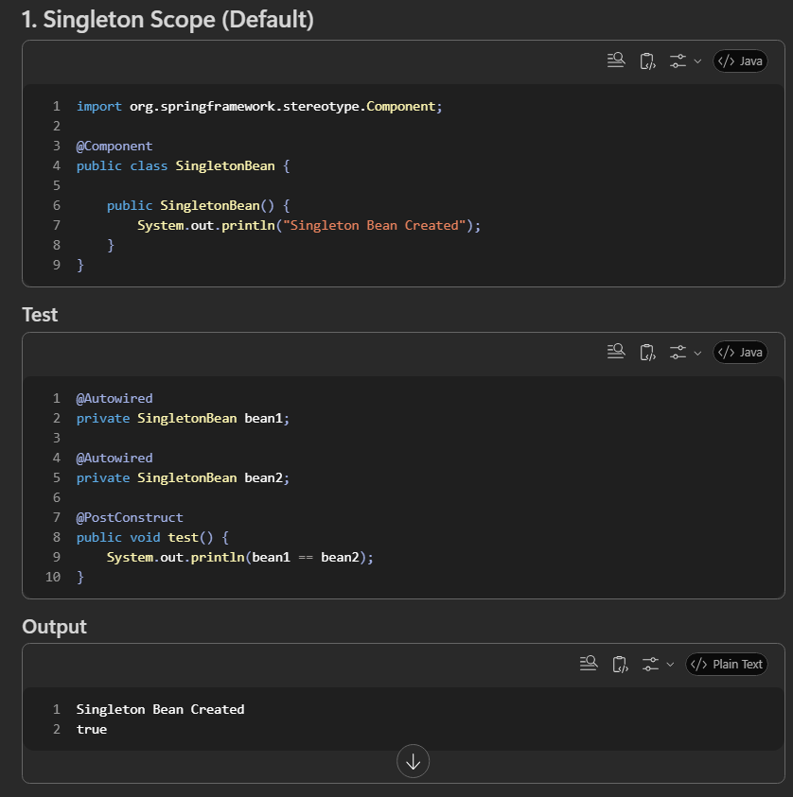
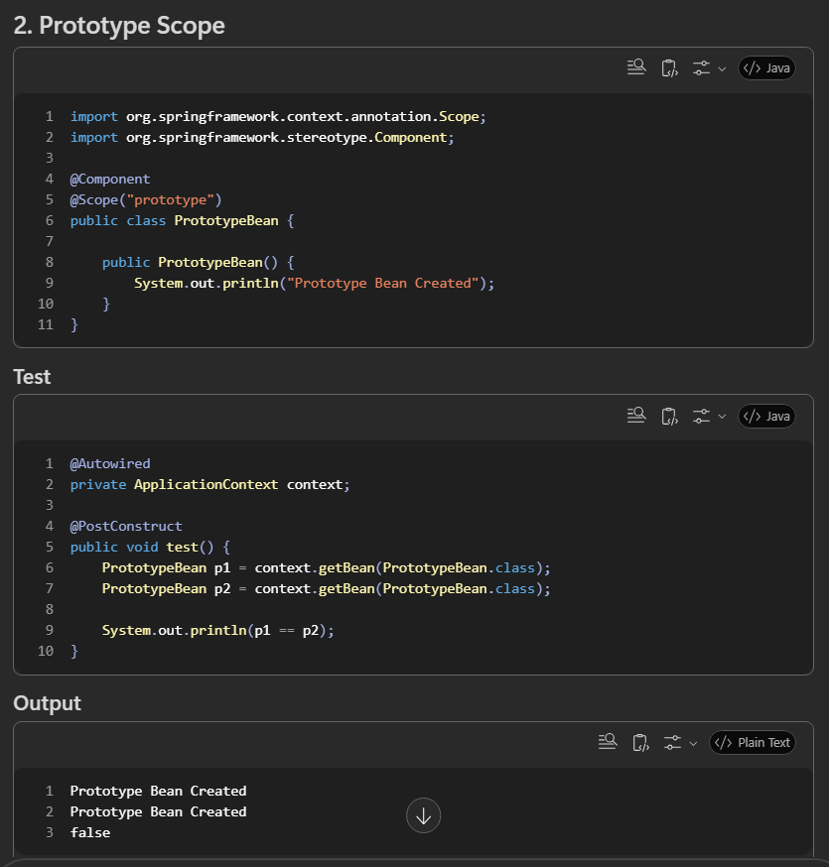
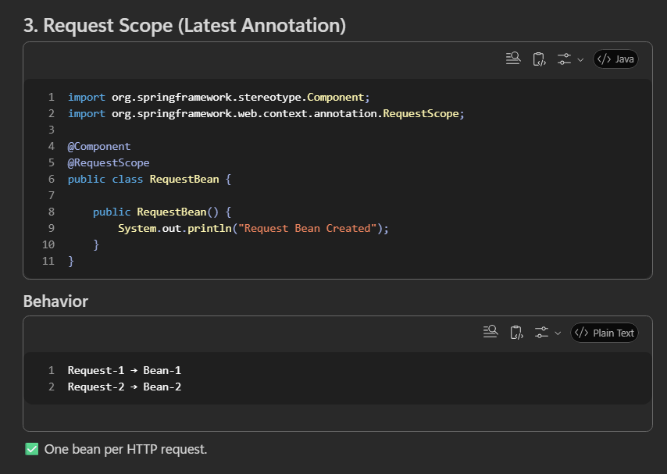
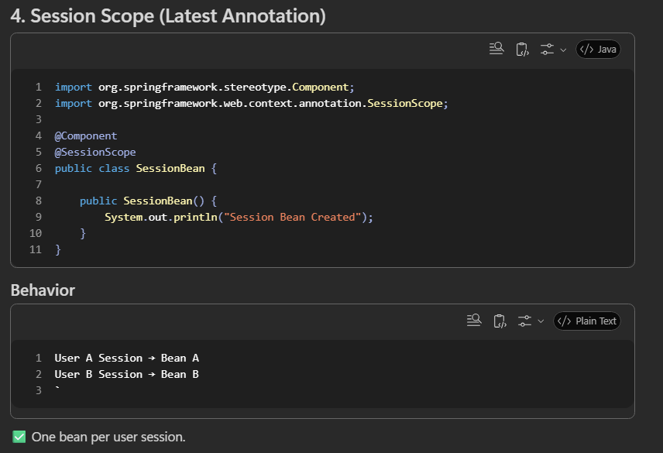
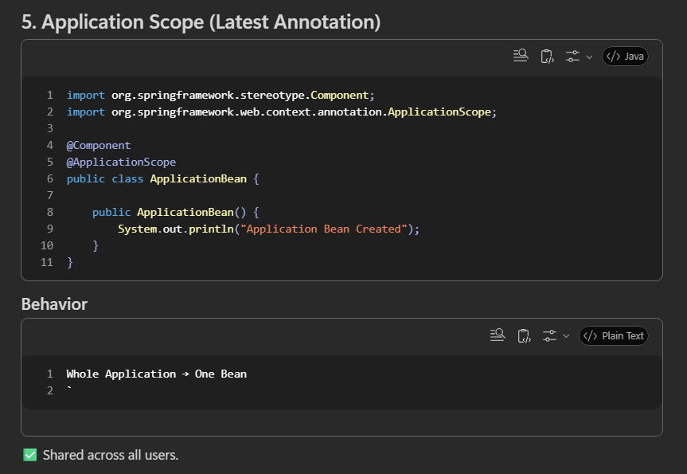

What is DI (Dependency Injection)?
Ans:- Dependency Injection (DI) is a design pattern where Spring provides the required objects (dependencies) to a class instead of the class creating them itself.
It helps achieve loose coupling, better maintainability, and easier testing.

What is Auto wiring?
Ans :- Auto wiring is a process or concept that refers to the spring framework capability to automatically resolve and inject dependency into your beans.
@Autowired:-
- When we need to inject dependency or bean into class then we use @Autowired.
- @Autowired is a Spring annotation used for Dependency Injection. It automatically finds a matching bean from the Spring container and injects it into another bean.
- It can be applied to fields, constructors, or setter methods, with constructor injection being the recommended approach.
- Auto wired always checked with annotation @Service, @Repository, @RestController, @Component).if this was then they inject the beans.

E.g:-
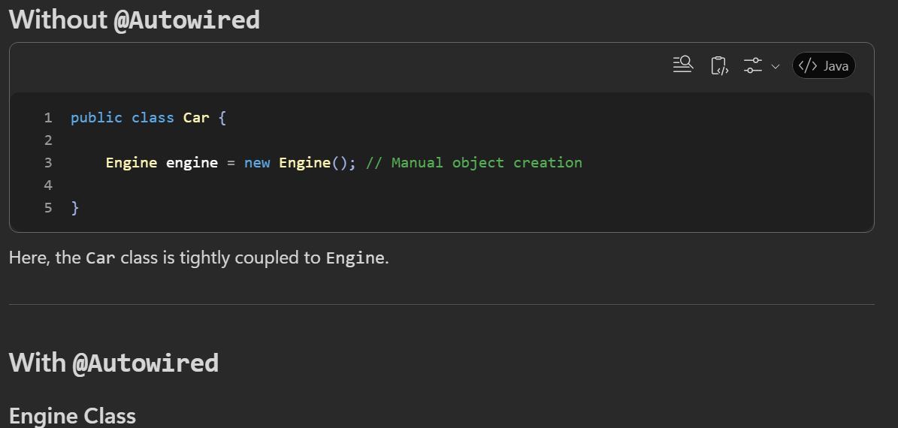
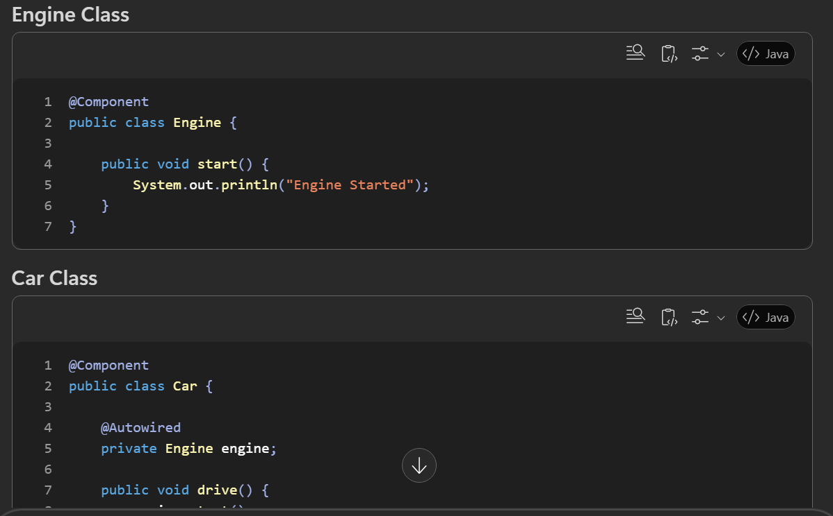
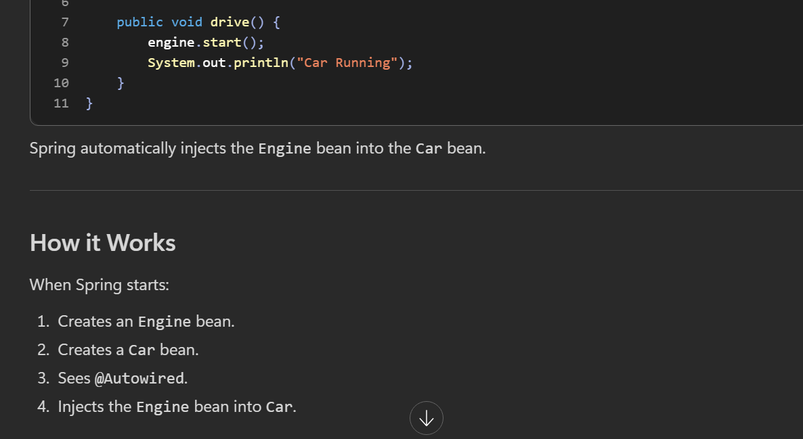
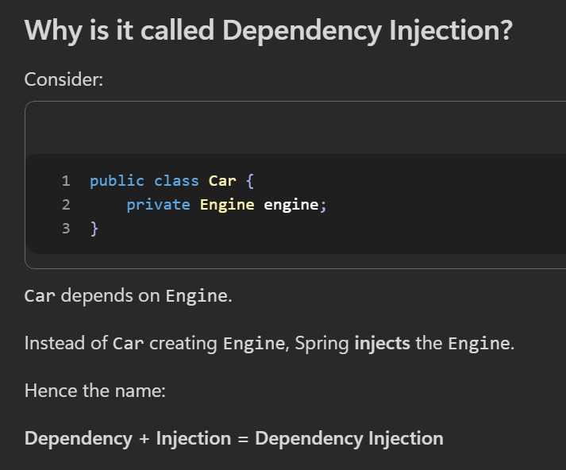

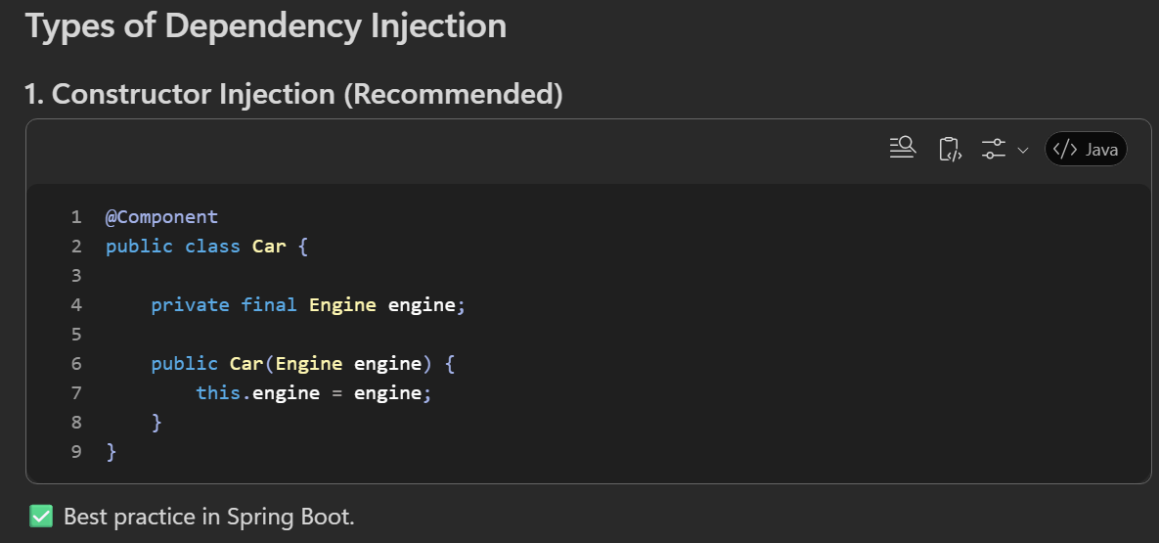
Advantages
- Dependence is mandatory.
- Supports final fields (immutability).
- Easy to unit test.
- Clearly shows required dependencies.
- Recommended by Spring.
Disadvantages
- Constructor can become long if there are many dependencies.

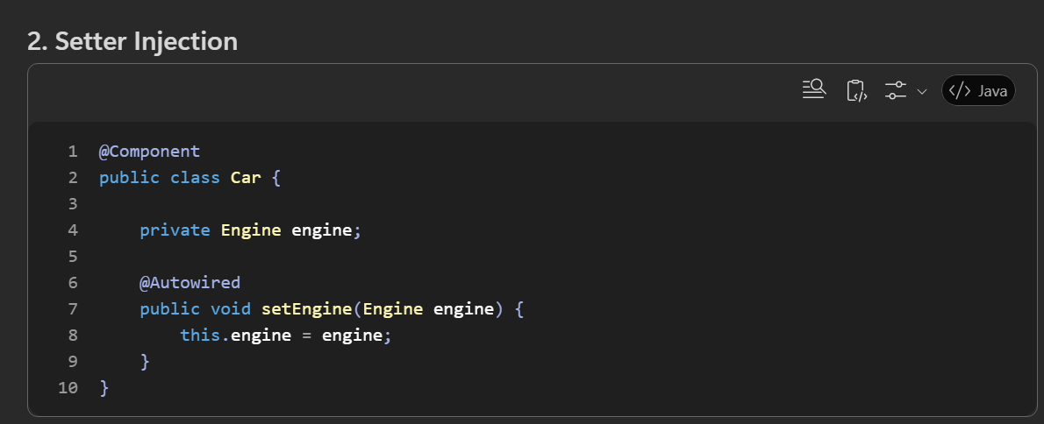
Advantages
- Useful for optional dependencies.
- Dependency can be changed later.
Disadvantages
- Object can be created without the dependency.
- Risk of NullPointerException if setter isn't called.
- Dependency is mutable

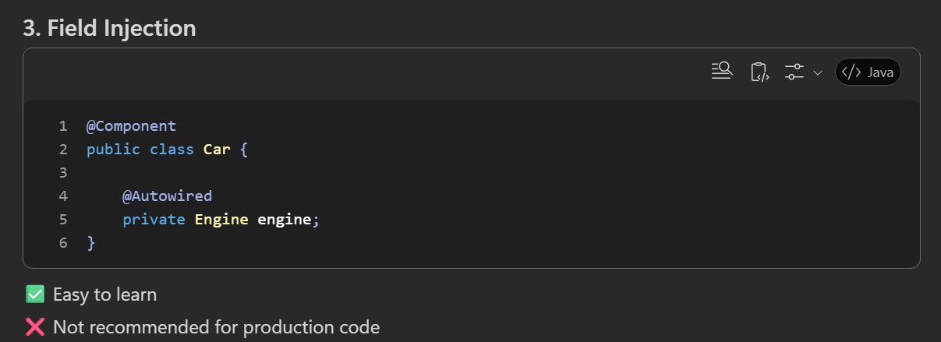
Advantages
- Less code.
- Easy for beginners.
Disadvantages
- It is harder to Unit test.
- Not recommended for production code.
What is @Qualifier Annotation in Spring Boot?
Ans :- @Qualifier is a Spring annotation used to resolve ambiguity problem when multiple beans of the same type exist in the Spring container.
When Spring performs Dependency Injection (DI) and finds more than one bean of a matching type, it throws a NoUniqueBeanDefinitionException. @Qualifier tells Spring exactly which bean should be injected.
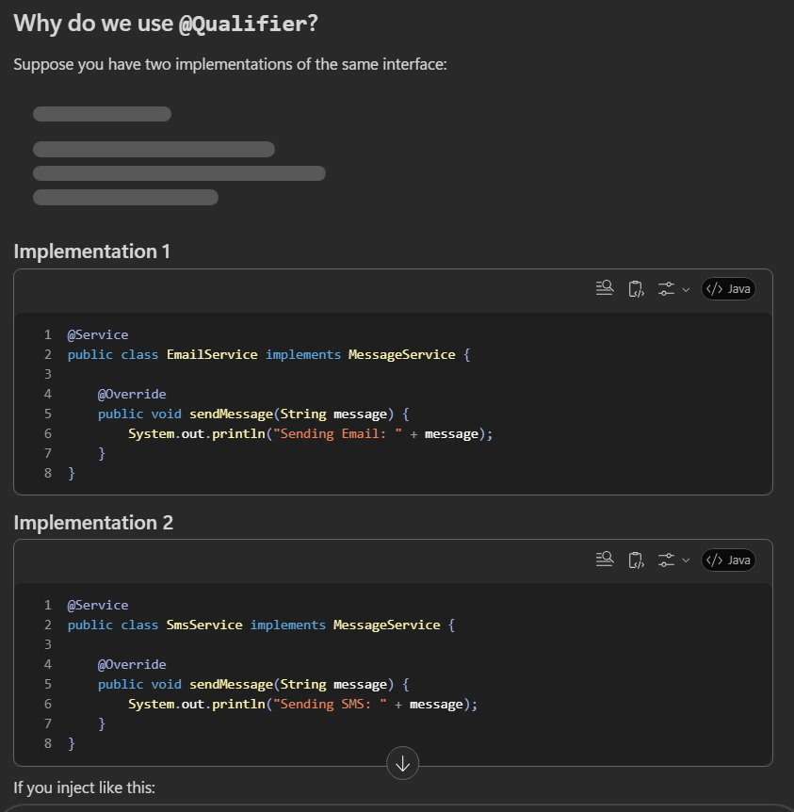
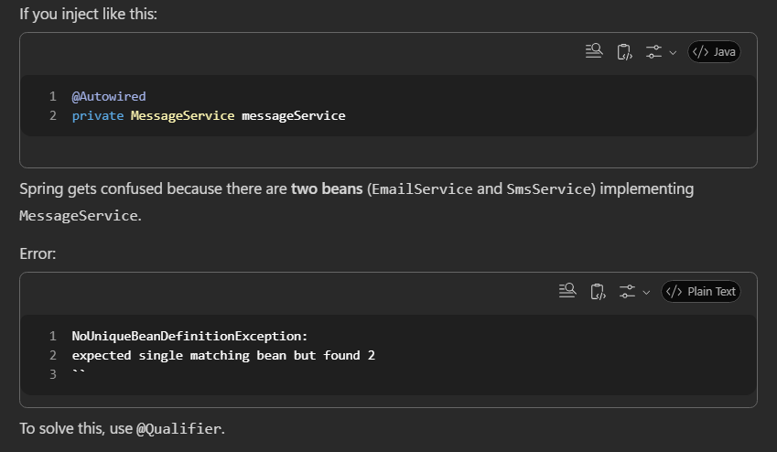
How to use in different injections method with Qualifier
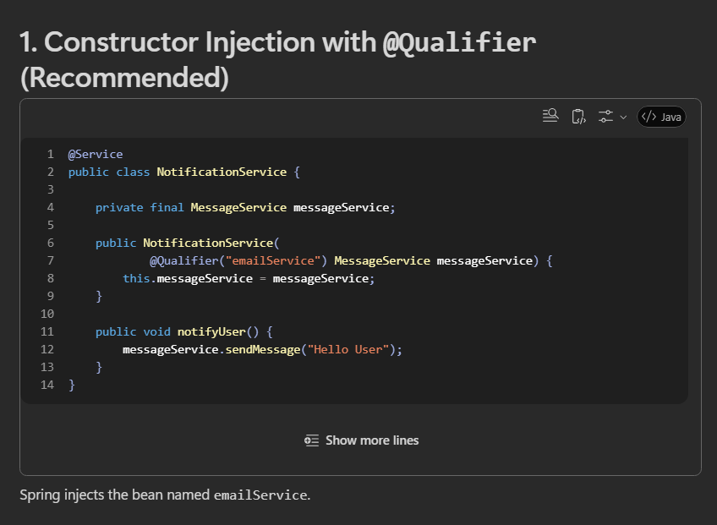
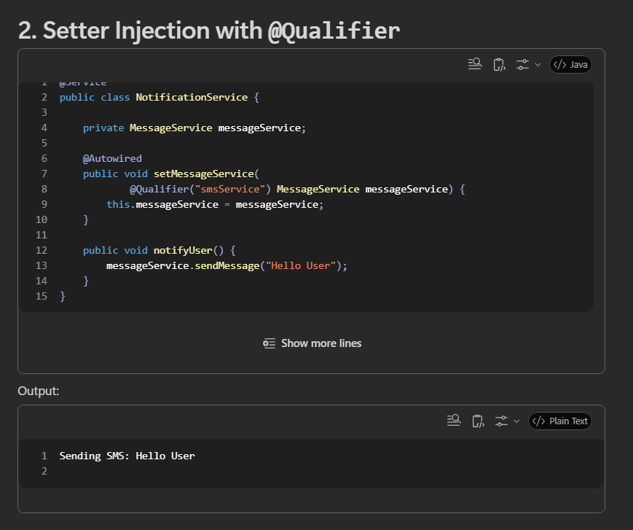
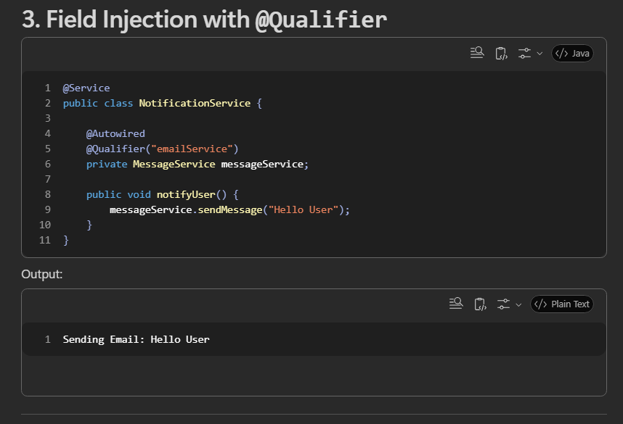
What is Spring MVC ?
It is a framework for build the web application in java. Which use the feature of spring like Dependency injections, IO Container.
Model – Handles data and business logic.
View – Displays data to the user (JSP, Thymeleaf, etc.).
Controller – Receives user requests and coordinates between Model and View.
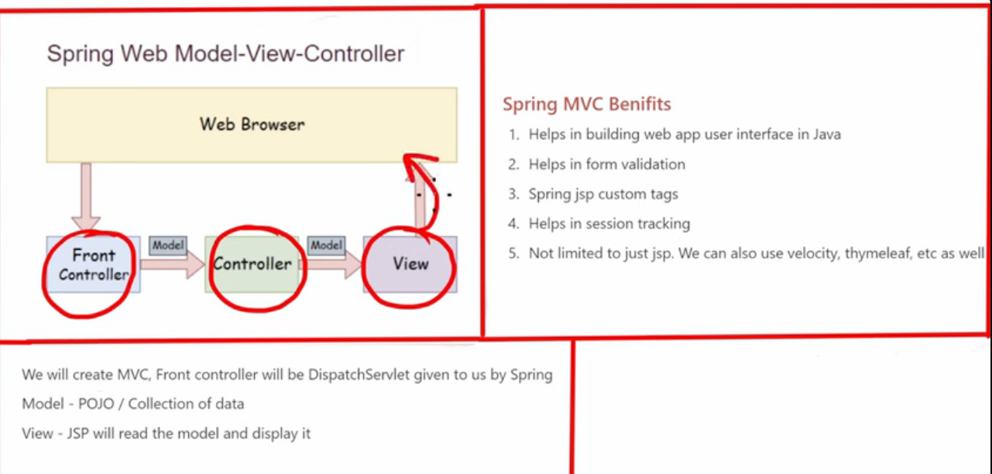
How Spring MVC Works:-
- A user sends an HTTP request.
- The DispatcherServlet (front controller) receives the request.
- The request is mapped to a Controller.
- The controller processes the request and interacts with services/business logic.
- Data is added to the Model.
- A View Resolver selects the appropriate view.
- The view renders the response and sends it back to the user
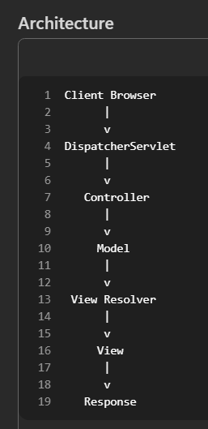

what is controller in spring?
Ans :- Controller is a class that handles incoming HTTP requests and returns a response to the client.
It acts as the entry point of your application's web layer.
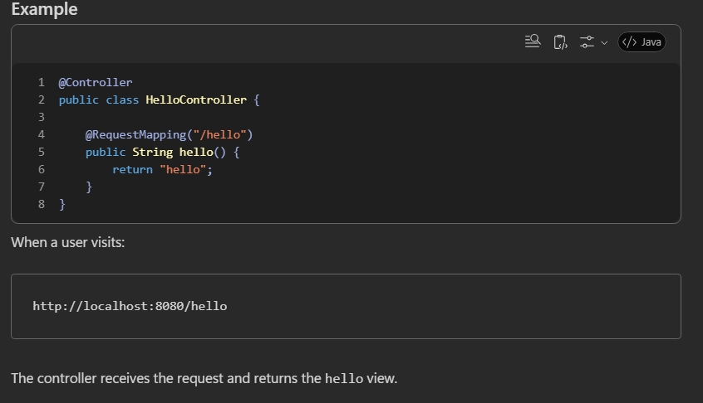

What is @RequestMapping and @Requestparam?
@RequestMapping :- used to map an HTTP request URL to a specific controller class or method..
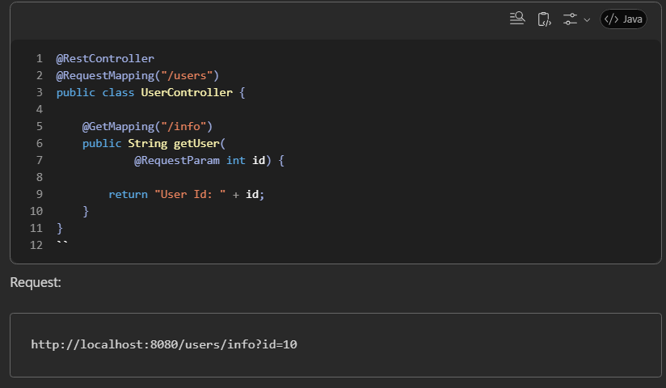
@RequestParam:- Used to read query parameter values from the URL and pass them to a controller method.
(?name=Ankit)
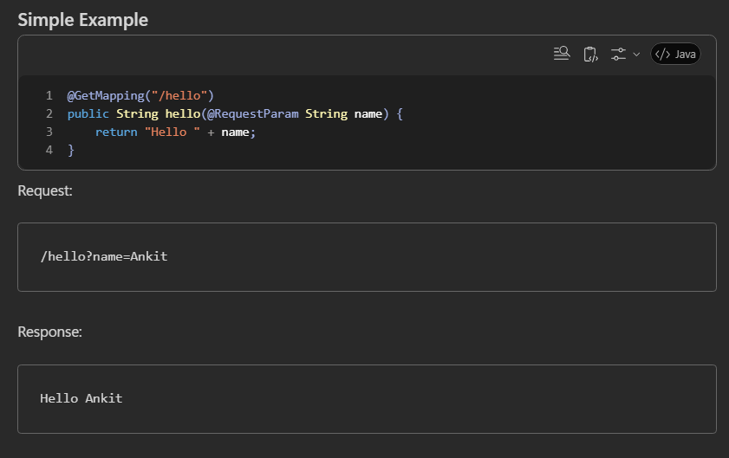

- Reads values from query parameters. ------------@RequestParam(defaultValue="Guest")
- Can be required or optional. ---------------@RequestParam(required=false)
- Can handle single or multiple values.----------------- @RequestParam List<Integer> ids

@PathVariable:- reads the values from the URL path.
